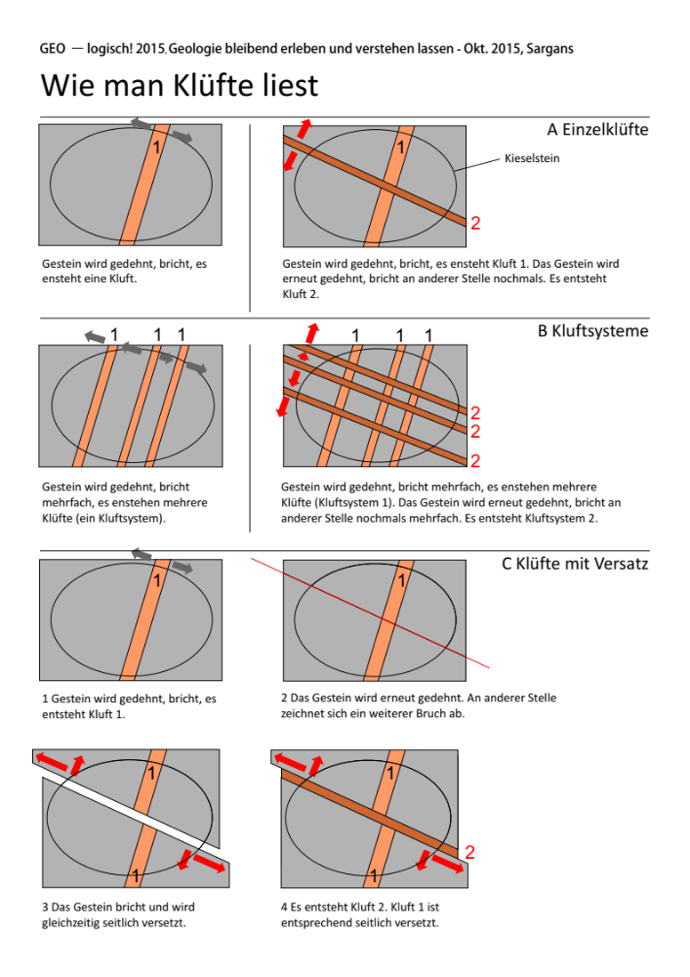
© Markus Weidmann & Jürg Meyer 2015

